pCMIS-4900-400
Team 2
Production Data Information System
Screen Sequence – Prototype (Wireframe)

Main User Interface Wireframe

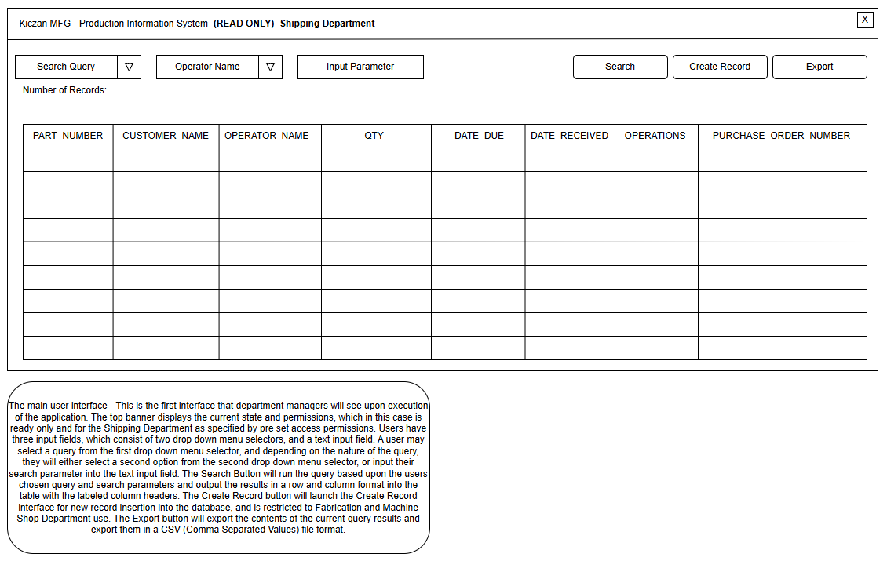

User Story | ERD
1, 2, 3, 4, 5 | PART_HISTORY:  PART_NUMBER,CUSTOMER_NAME  OPERATOR_NAME, QTY, DATE_DUE  DATE_RECEIVED, OPERATIONS  PURCHASE_ORDER_NUMBER

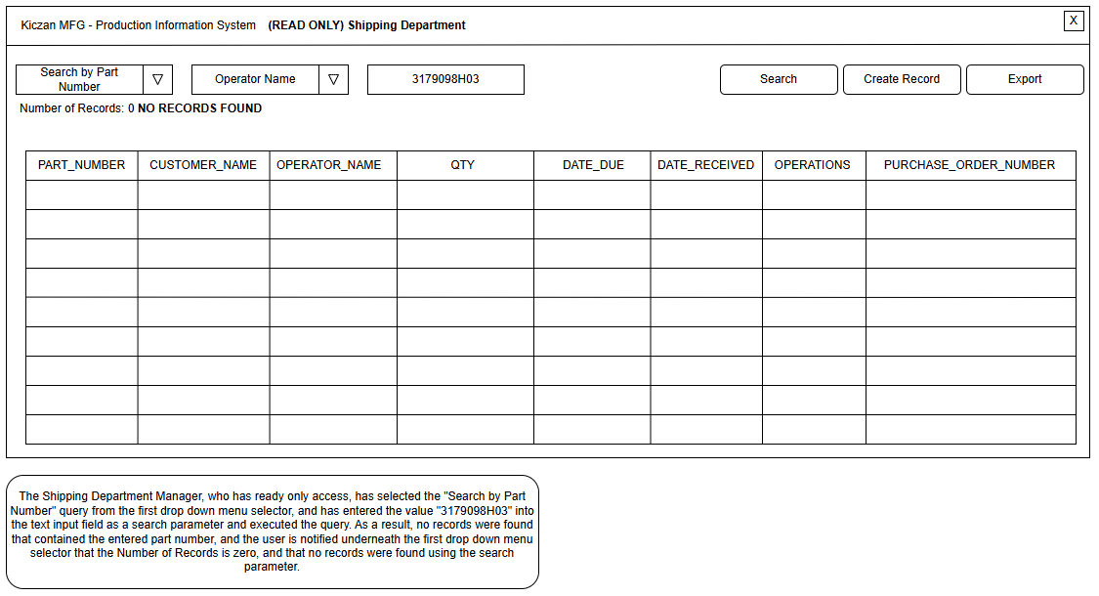

User Story | ERD
1 | CUSTOMERS:  CUSTOMER_ID, CUSTOMER_NAME  OPERATORS:  OPERATOR_ID, OPERATOR_NAME  JOBS:  JOB_ID  PART_HISTORY:  PART_NUMBER,CUSTOMER_NAME  OPERATOR_NAME, QTY, DATE_DUE  DATE_RECEIVED, OPERATIONS  PURCHASE_ORDER_NUMBER

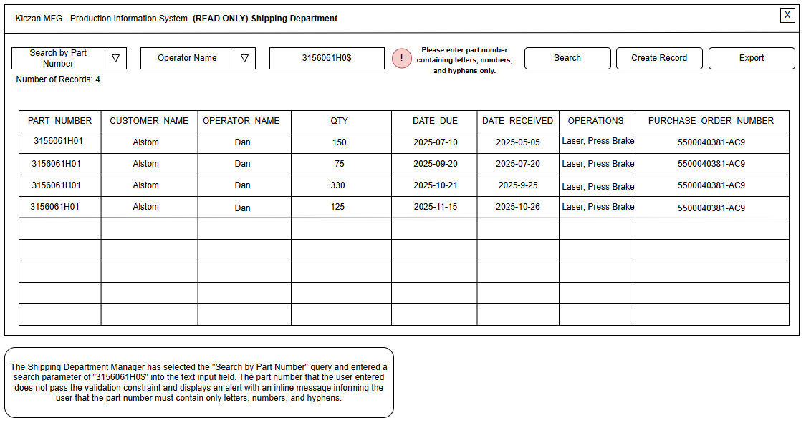

User Story | ERD
1, 6 | CUSTOMERS:  CUSTOMER_ID, CUSTOMER_NAME  OPERATORS:  OPERATOR_ID, OPERATOR_NAME  JOBS:  JOB_ID  PART_HISTORY:  PART_NUMBER,CUSTOMER_NAME  OPERATOR_NAME, QTY, DATE_DUE  DATE_RECEIVED, OPERATIONS  PURCHASE_ORDER_NUMBER

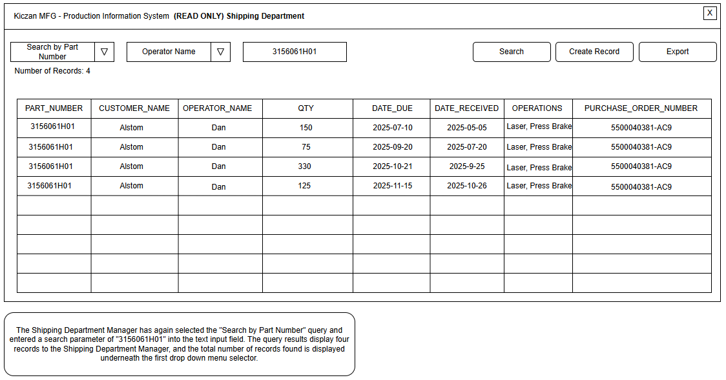

User Story | ERD
1 | CUSTOMERS:  CUSTOMER_ID, CUSTOMER_NAME  OPERATORS:  OPERATOR_ID, OPERATOR_NAME  JOBS:  JOB_ID  PART_HISTORY:  PART_NUMBER,CUSTOMER_NAME  OPERATOR_NAME, QTY, DATE_DUE  DATE_RECEIVED, OPERATIONS  PURCHASE_ORDER_NUMBER

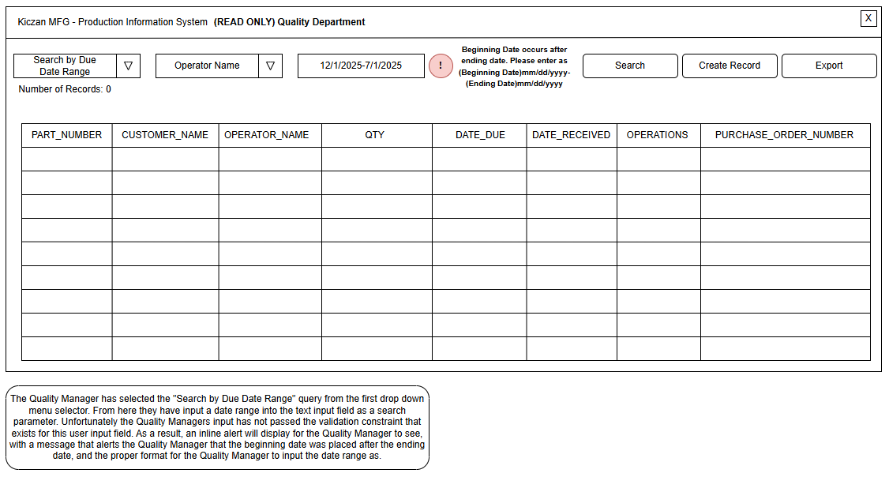

User Story | ERD
2, 6 | CUSTOMERS:  CUSTOMER_ID, CUSTOMER_NAME  OPERATORS:  OPERATOR_ID, OPERATOR_NAME  JOBS:  JOB_ID  PART_HISTORY:  PART_NUMBER,CUSTOMER_NAME  OPERATOR_NAME, QTY, DATE_DUE  DATE_RECEIVED, OPERATIONS  PURCHASE_ORDER_NUMBER

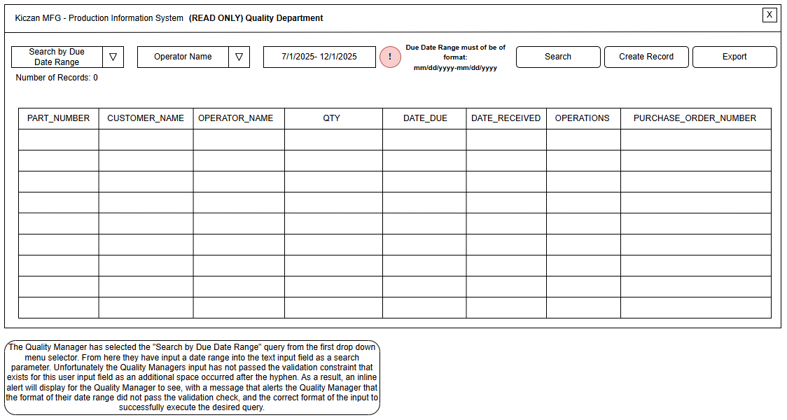

User Story | ERD
2, 6 | CUSTOMERS:  CUSTOMER_ID, CUSTOMER_NAME  OPERATORS:  OPERATOR_ID, OPERATOR_NAME  JOBS:  JOB_ID  PART_HISTORY:  PART_NUMBER,CUSTOMER_NAME  OPERATOR_NAME, QTY, DATE_DUE  DATE_RECEIVED, OPERATIONS  PURCHASE_ORDER_NUMBER

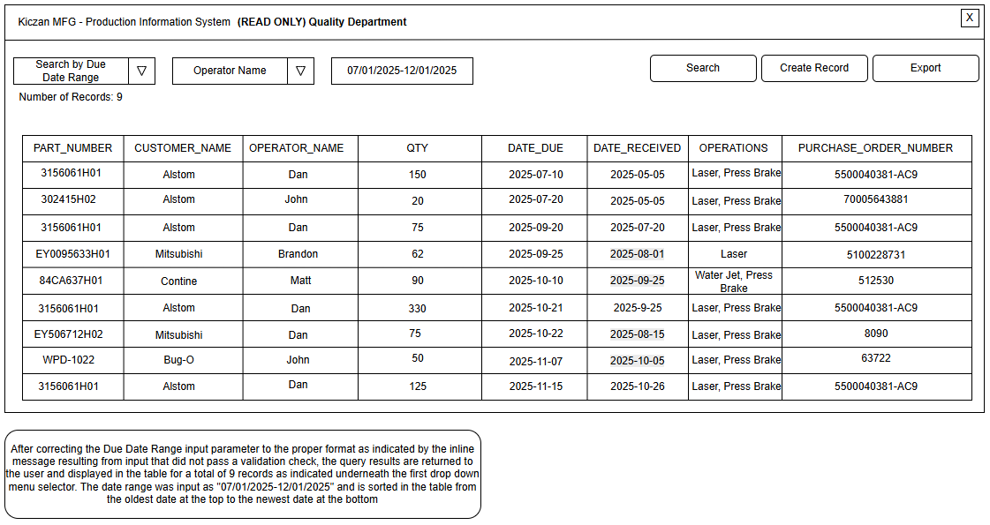

User Story | ERD
2 | CUSTOMERS:  CUSTOMER_ID, CUSTOMER_NAME  OPERATORS:  OPERATOR_ID, OPERATOR_NAME  JOBS:  JOB_ID  PART_HISTORY:  PART_NUMBER,CUSTOMER_NAME  OPERATOR_NAME, QTY, DATE_DUE  DATE_RECEIVED, OPERATIONS  PURCHASE_ORDER_NUMBER

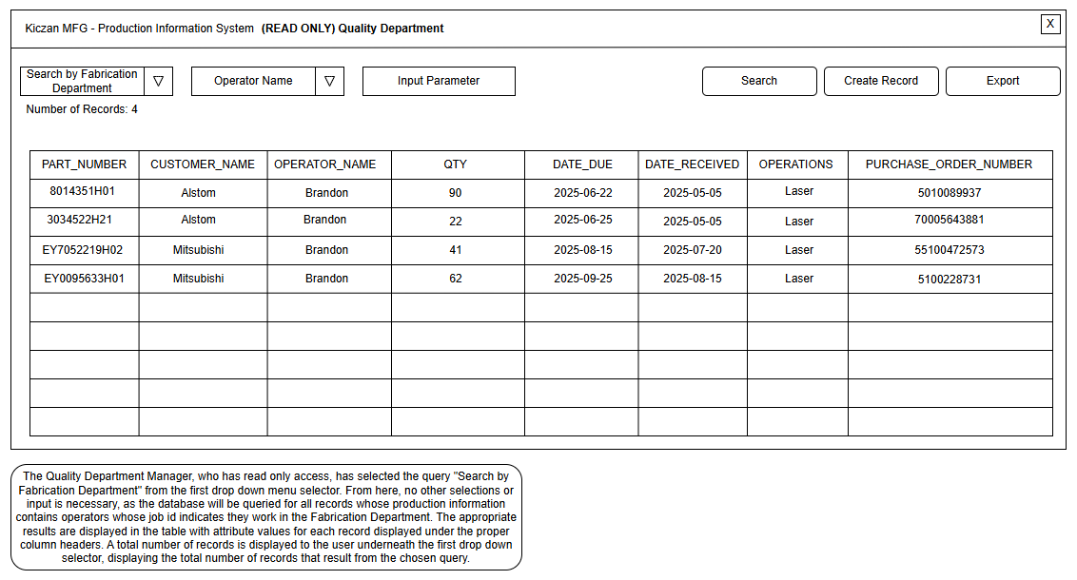

User Story | ERD
4 | CUSTOMERS:  CUSTOMER_ID, CUSTOMER_NAME  OPERATORS:  OPERATOR_ID, OPERATOR_NAME  JOBS:  JOB_ID  PART_HISTORY:  PART_NUMBER,CUSTOMER_NAME  OPERATOR_NAME, QTY, DATE_DUE  DATE_RECEIVED, OPERATIONS  PURCHASE_ORDER_NUMBER

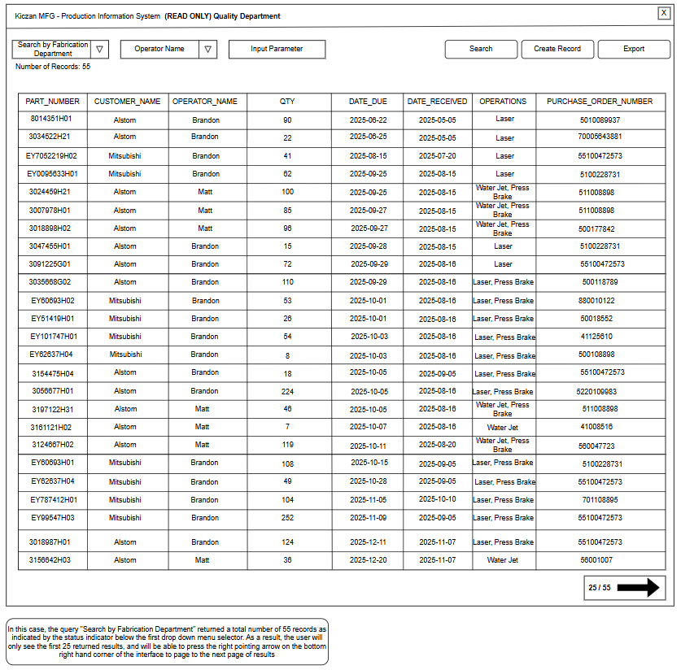

User Story | ERD
4, 7 | CUSTOMERS:  CUSTOMER_ID, CUSTOMER_NAME  OPERATORS:  OPERATOR_ID, OPERATOR_NAME  JOBS:  JOB_ID  PART_HISTORY:  PART_NUMBER,CUSTOMER_NAME  OPERATOR_NAME, QTY, DATE_DUE  DATE_RECEIVED, OPERATIONS  PURCHASE_ORDER_NUMBER

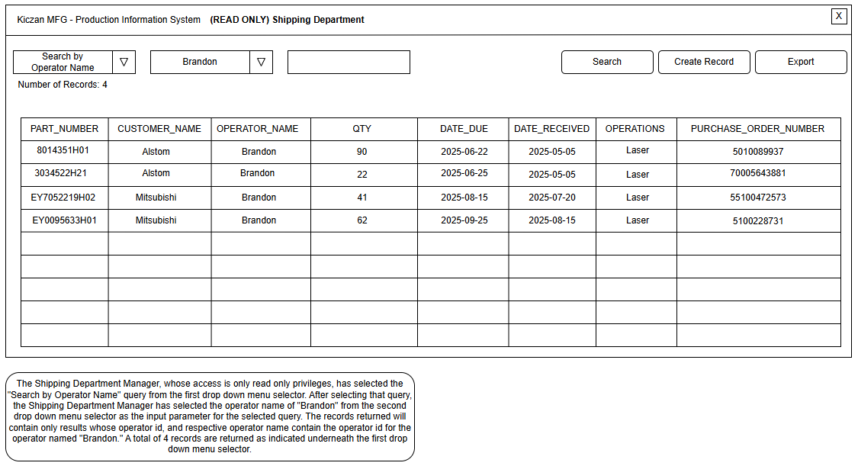

User Story | ERD
3 | CUSTOMERS:  CUSTOMER_ID, CUSTOMER_NAME  OPERATORS:  OPERATOR_ID, OPERATOR_NAME  JOBS:  JOB_ID  PART_HISTORY:  PART_NUMBER,CUSTOMER_NAME  OPERATOR_NAME, QTY, DATE_DUE  DATE_RECEIVED, OPERATIONS  PURCHASE_ORDER_NUMBER

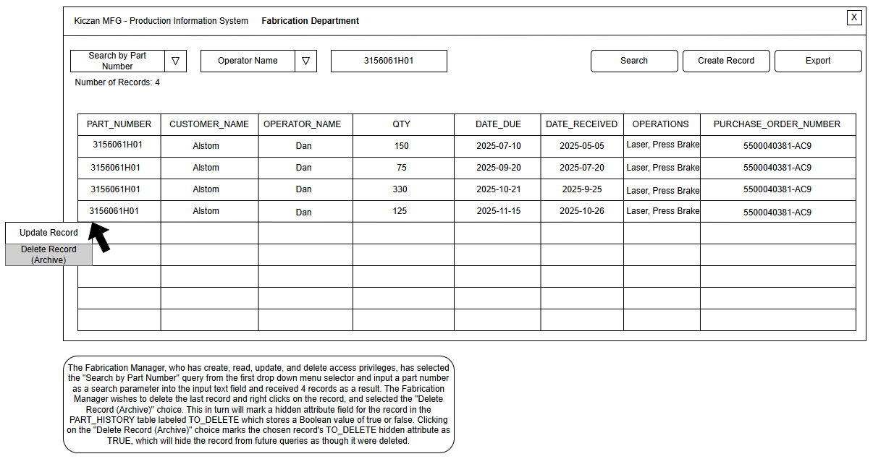

User Story | ERD
5 | PART_HISTORY:  PART_NUMBER  CUSTOMER_NAME  OPERATOR_NAME  QTY  DATE_DUE  DATE_RECEIVED  OPERATIONS  PURCHASE_ORDER_NUMBER  TO_DELETE

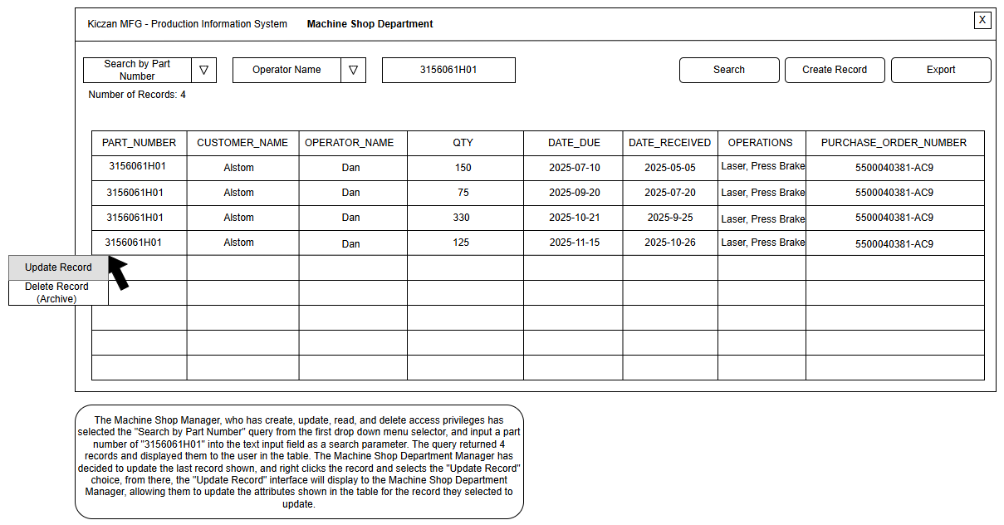

User Story | ERD
5 | PART_HISTORY:  PART_NUMBER  CUSTOMER_NAME  OPERATOR_NAME  QTY  DATE_DUE  DATE_RECEIVED  OPERATIONS  PURCHASE_ORDER_NUMBER

Create Record Interface Wireframe

